SPRING BOOT ADAVNECED TOPICS:

============

1. Content negotiation;

if you want xml:

add

<!-- https://mvnrepository.com/artifact/com.fasterxml/jackson-xml-databind -->

<dependency>

<groupId>com.fasterxml</groupId>

<artifactId>jackson-xml-databind</artifactId>

<version>0.6.2</version>

</dependency>

annd send header with application/xml in request header.

-----------

2. Actutator:

in order to show the performance of the application in the form of heakth , metrics, diagnostics etc..

we will use actuators app.

it tells how much of the jvm memory used and what are the requests available and endpoints URI's exposed.

pom.xml:

<dependency>

<groupId>org.springframework.boot</groupId>

<artifactId>spring-boot-starter-actuator</artifactId>

</dependency>

and change the application.properties:

server.port = 8761

management.server.port=8761 (same as server port)

HAL browser:

if you want to show the healt and metrics in the form of UI way. use spring data HAL browser dependency.

<dependency>

<groupId>org.springframework.data</groupId>

<artifactId>spring-data-rest-hal-browser</artifactId>

<version>3.0.8.RELEASE</version>

</dependency>

and navigate to localhost:8080/ to see thr UI.

Exception handling:

Suppose if the required endpoint uRI is not available in the server, you will get the **“Internal server error 500” . but , this is nt the fault of the server .**

Because the server is avaialbe for the URI may not available, in that case we should have the response luke “**Error 404 request not found**”.

How to do?

Suppose :

<http://localhost:8762/employees/2> is not available then,

Controller class:

getEmployees(@PathVaraiblae(“empid”)String emppid))->method

{  
//fetcth the record from the db using controller->service->repository

If(emp==null) //not found then

{

Throw new ResourceNotFoundException();

}

}

@ResponseStatus(HttpStstus.NOT_FOUND)

Class ResourceNotFoundException extends RuntimeException{

}

Before:

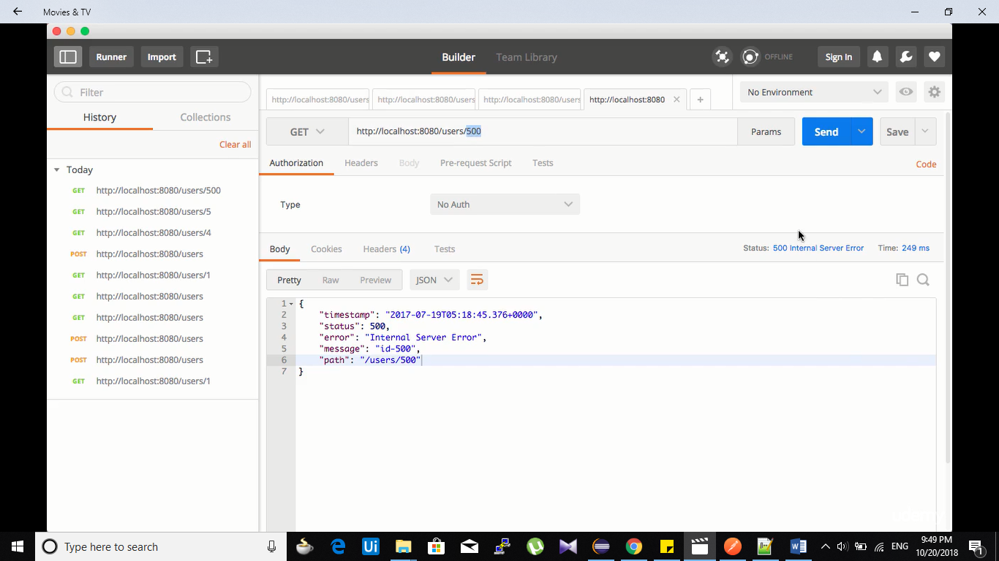

After:

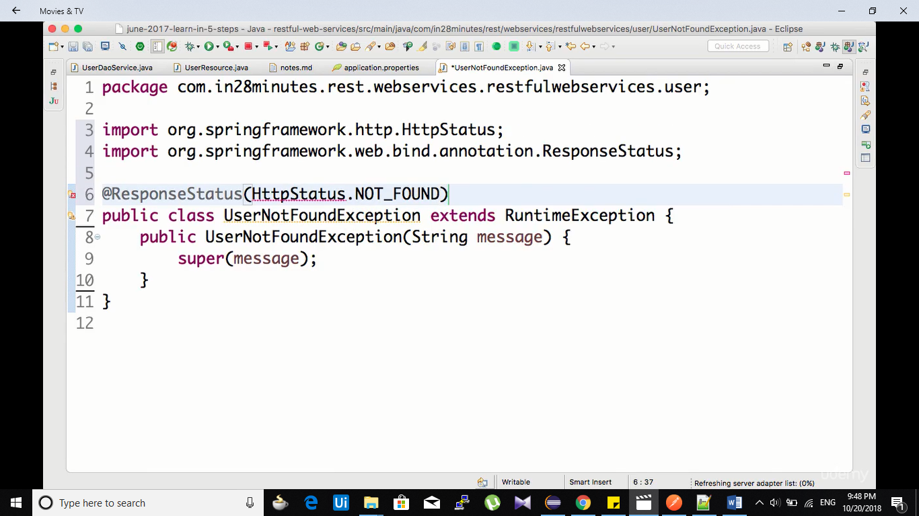

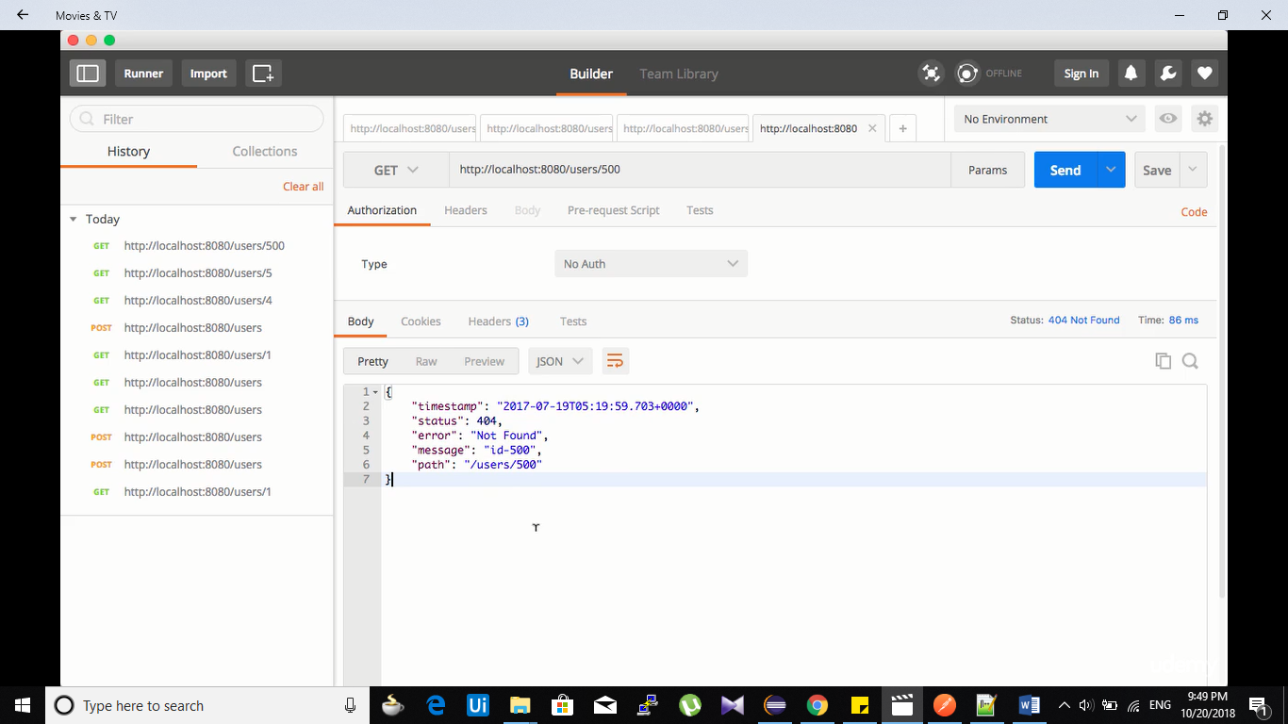

Result:

Now you will get 404 not found error

2. Generics exceptions:

If we want to have generic exceptions messages for all the resoucres effectively, then we need to use

**ResponseEntityExceptionHandler.**

**Note: whenever request executes, we can have @InitBinder, @ModelAttribute and @ExceptionHandler types annotations.**

**Each request has to go through this annotations when these are specified.**

**We will have @ControllerAdvice which will makesure that FOR every request this anooations will work as we use them.**

**Generic classes:**

**@Confgiration**

**@ControllerAdvice**

**Publc class GenericesourceException extends ResponseEntityExceptionHandler**

**{**

**@ExceptionHandler(Exception.class)**

**Response<Object> handleAllMethod()**

**{**

**ExceptionResponseClass exception=new ExceptionResponseClass (set fields);**

**// template which has default respoinses for all the requests failires.**

**Return Response<Object>(exception,HttpStatus.INTERNAL_SERVER_ERROR)**

**}**

**ExceptionResponseClass template**

**@ExceptionHandler(UserNotFoundException.class)**

**Response<Object> handleUserNotFoungMethod()**

**{**

**//**

**Return Response<Object>(exception,HttpStatus.INTERNAL_SERVER_ERROR)**

**}**

**}**

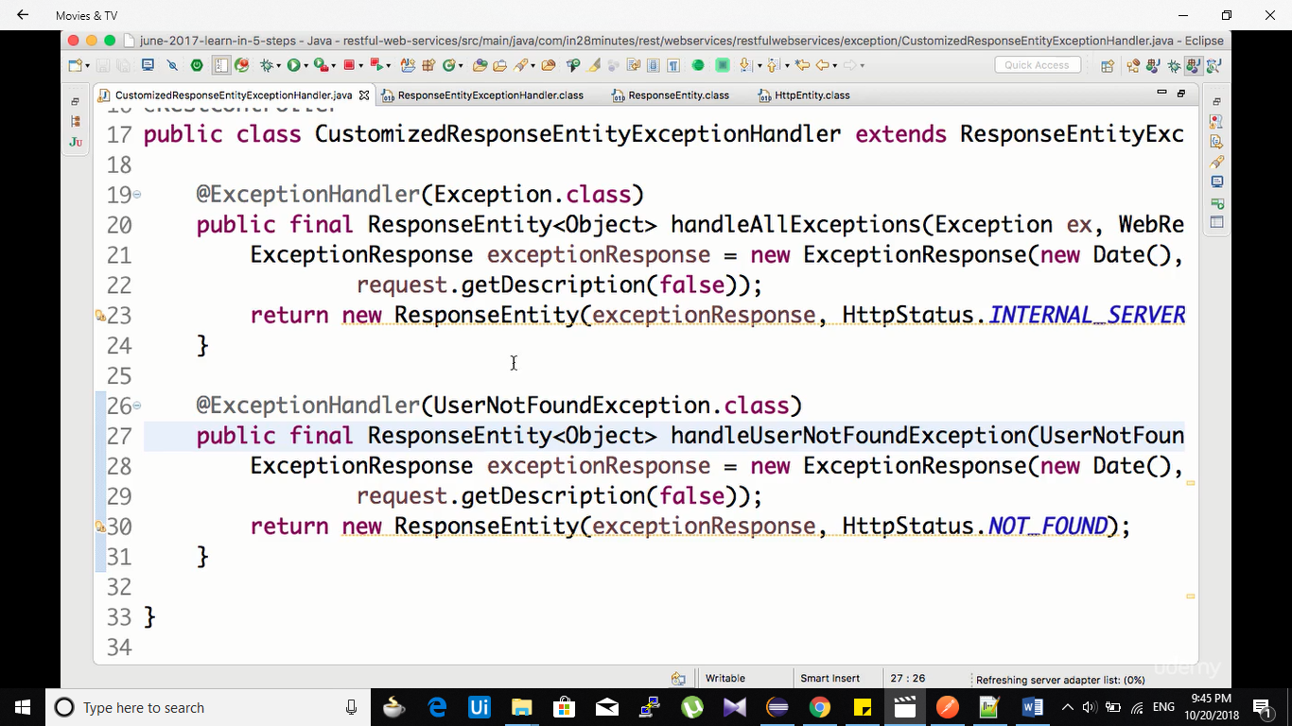

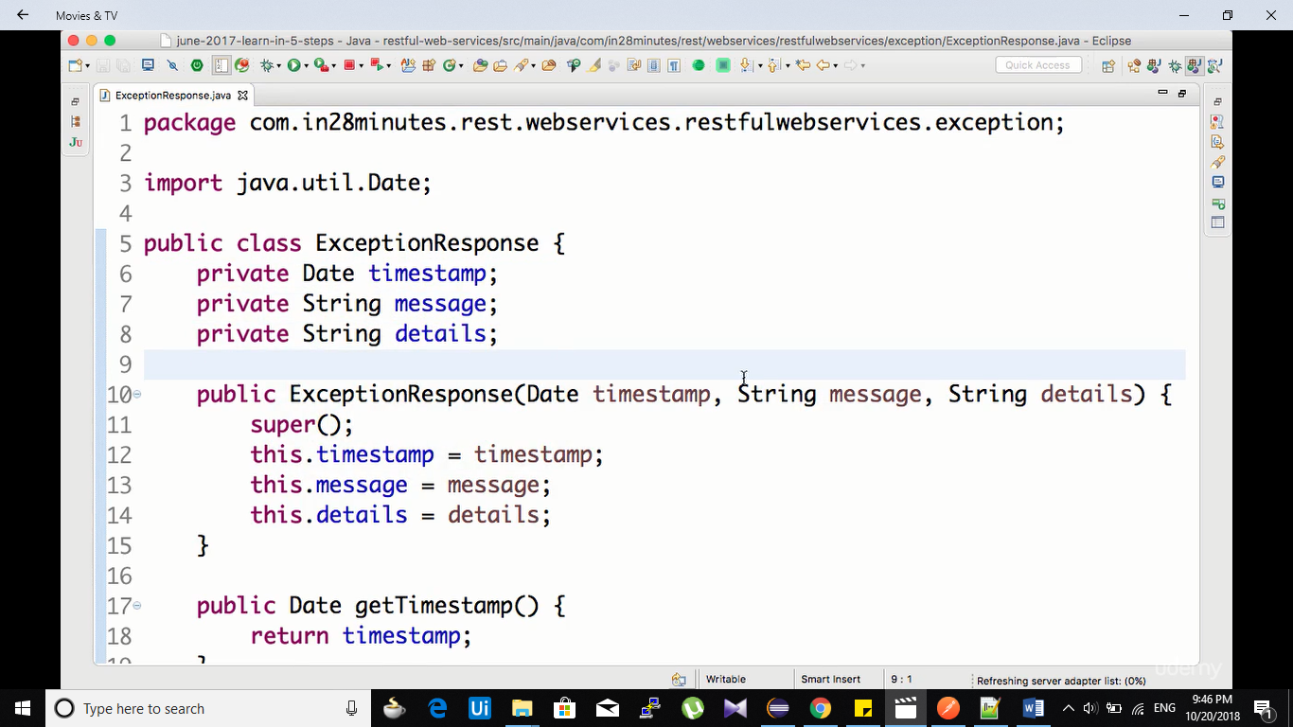

**Throwing exception class:**

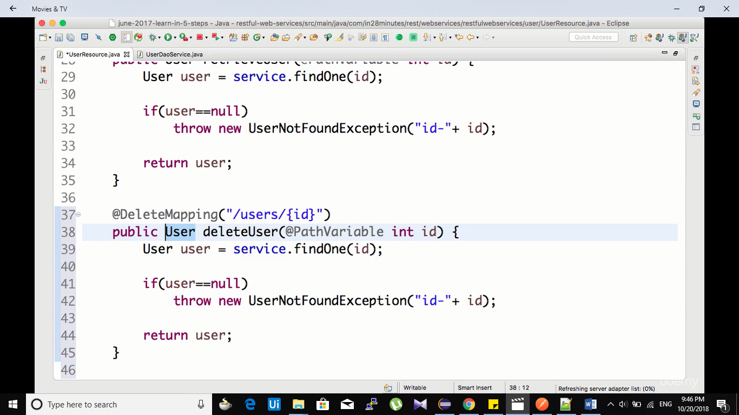**x**

**Sending the url to response header which is posted or deleted:**

**Code:**

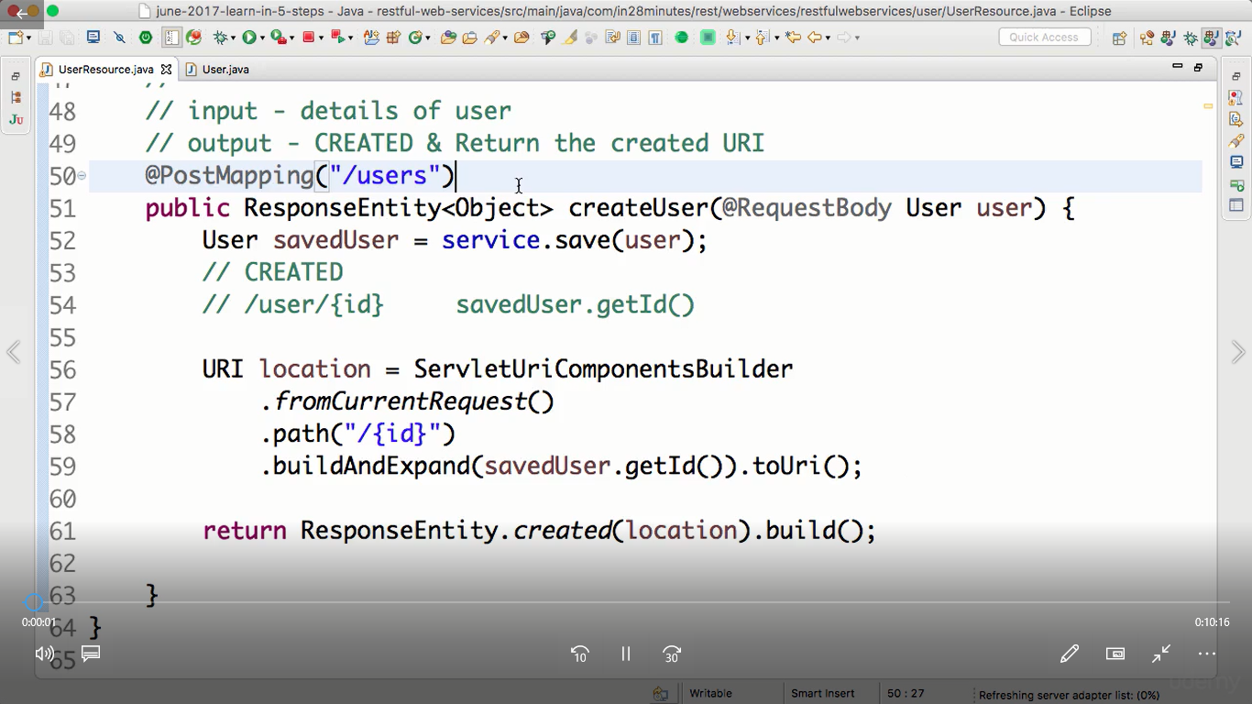

**Before:**

**No location is speicifed.**

**After:**

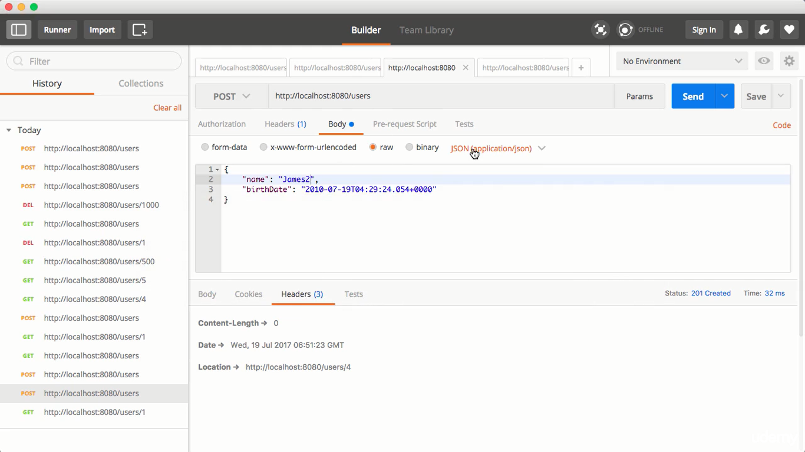

**Bean validation:**

**If we want to make the validations on the bean we can do.**

**But we if we wan tto send the validation message to the response. We can do this.**

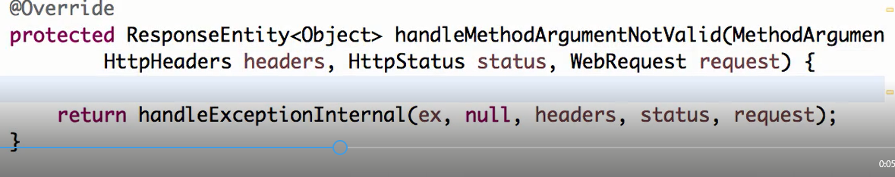

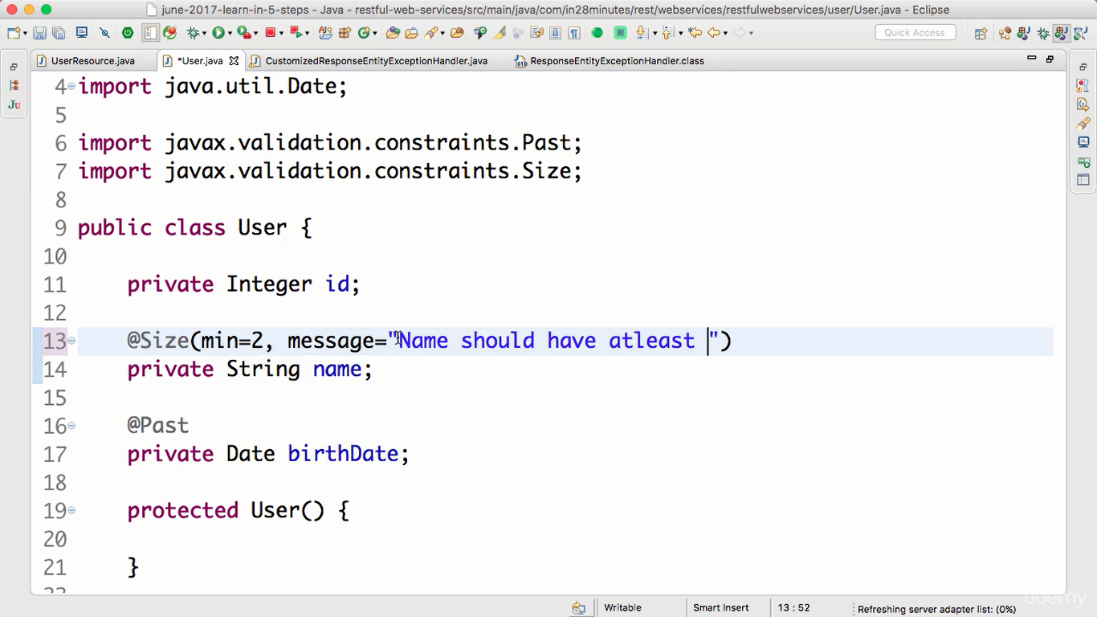

**Controller class:** 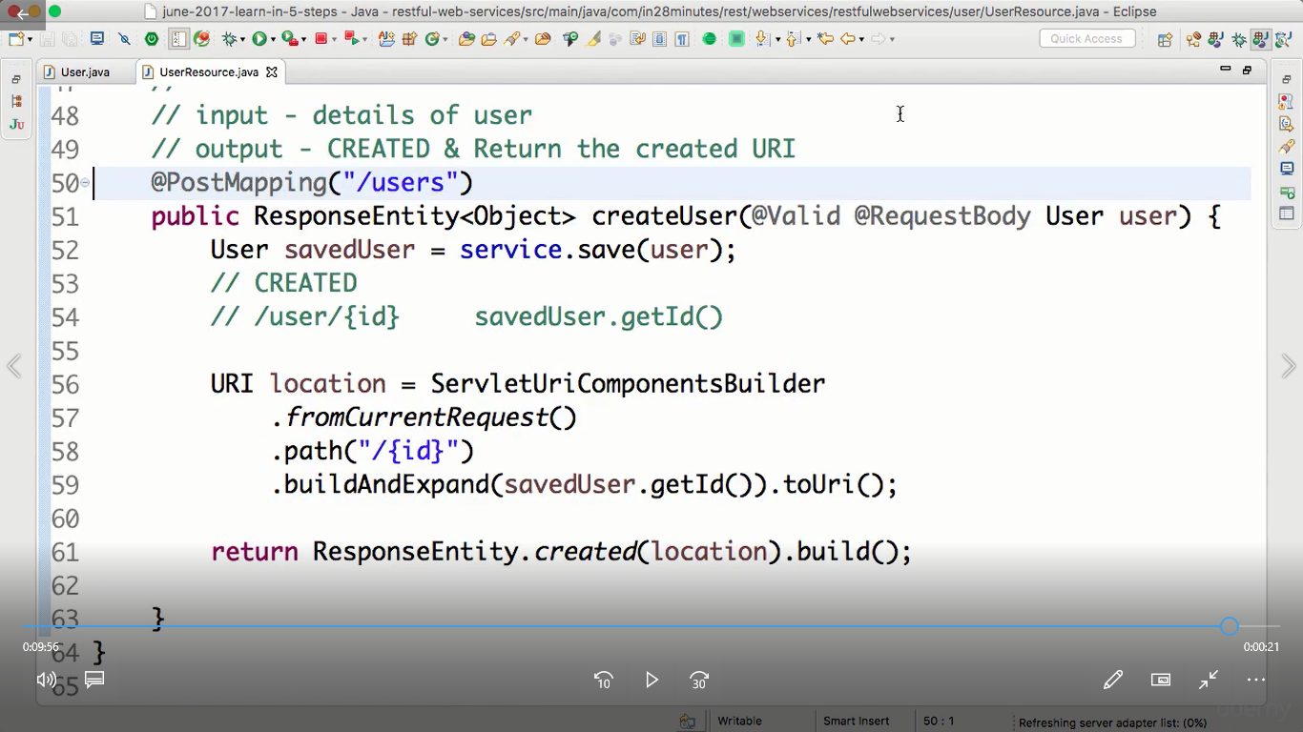

**Error in response we got:**

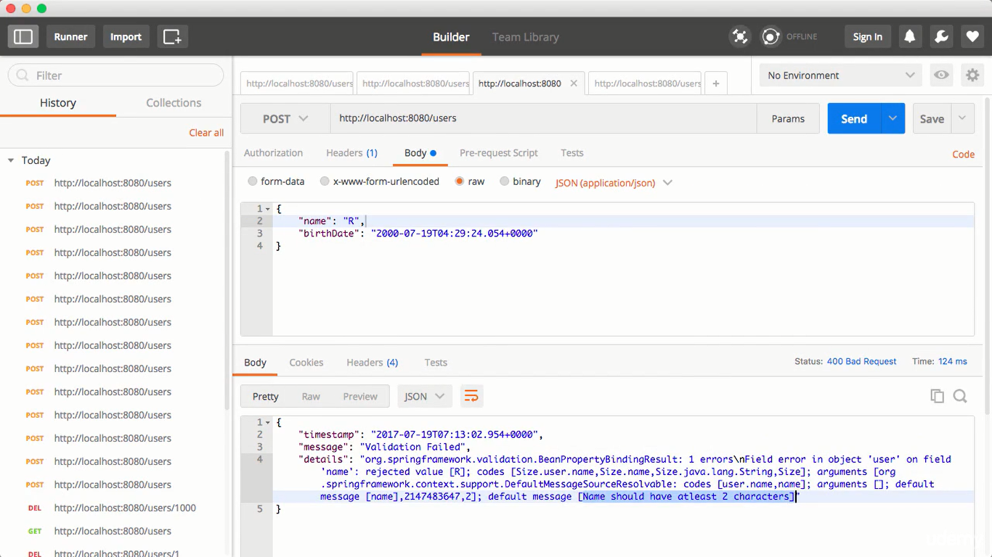

**HATEOAS:**

**If we want to send the response and along with that all the recommended links as a response to the request. We will use HATEOAS.**

**INote:**

**The mthods will be converyed to links and it will be attached to the request.**

**ControllerLinkBuider class.**

**Pom.xml:**

**Spring-boot-starter-hateoas**

**Method:**

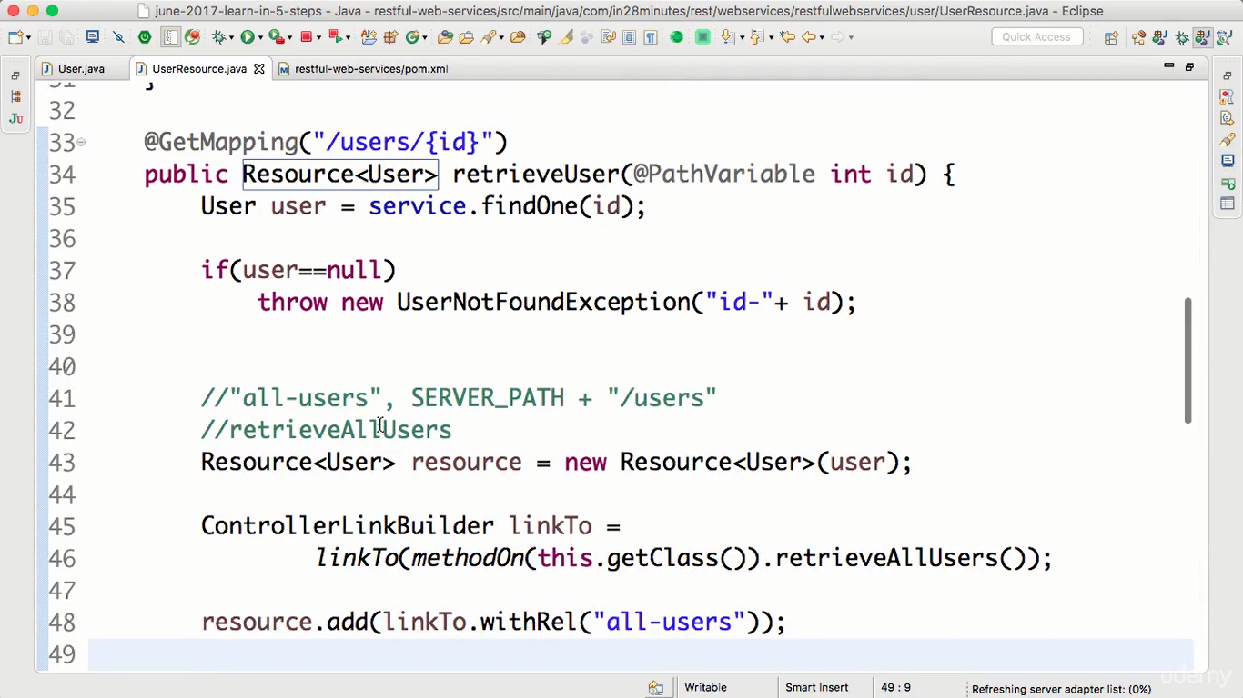

2. Internatlionastaion:

We want to build our application so that it is compatible to all the languages.

W ewill use i18n for spring boot.

We will have to config 3 m=things.

1. Application_en,applicatyion_fr.props all the porps
2. Their bean defintions in using ResourceBundleMessageSource.

LocalResource bean definition

Main : LocalResource class.

Without spring boot config:

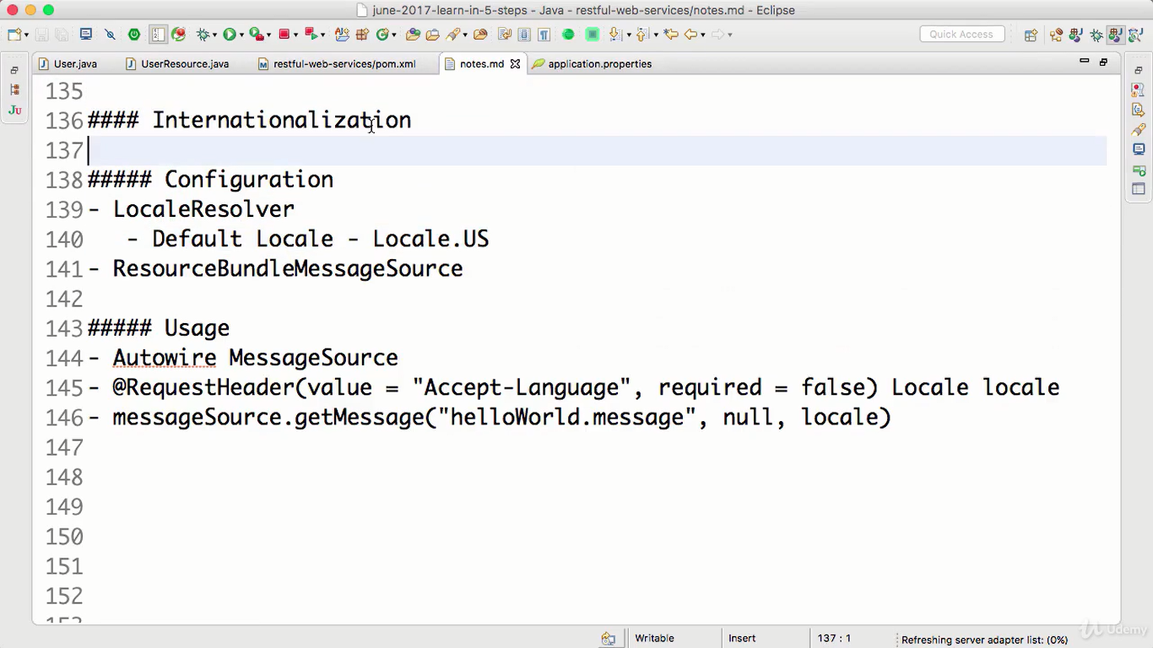

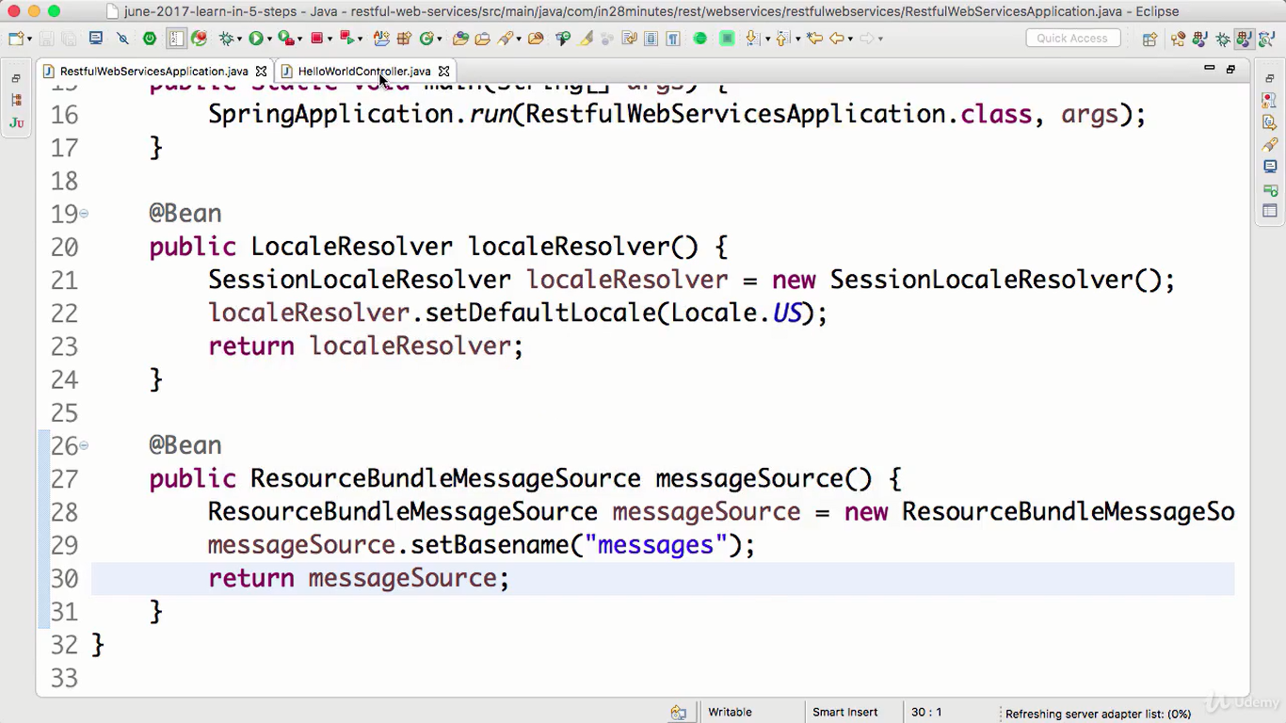

@RequestHeqader:

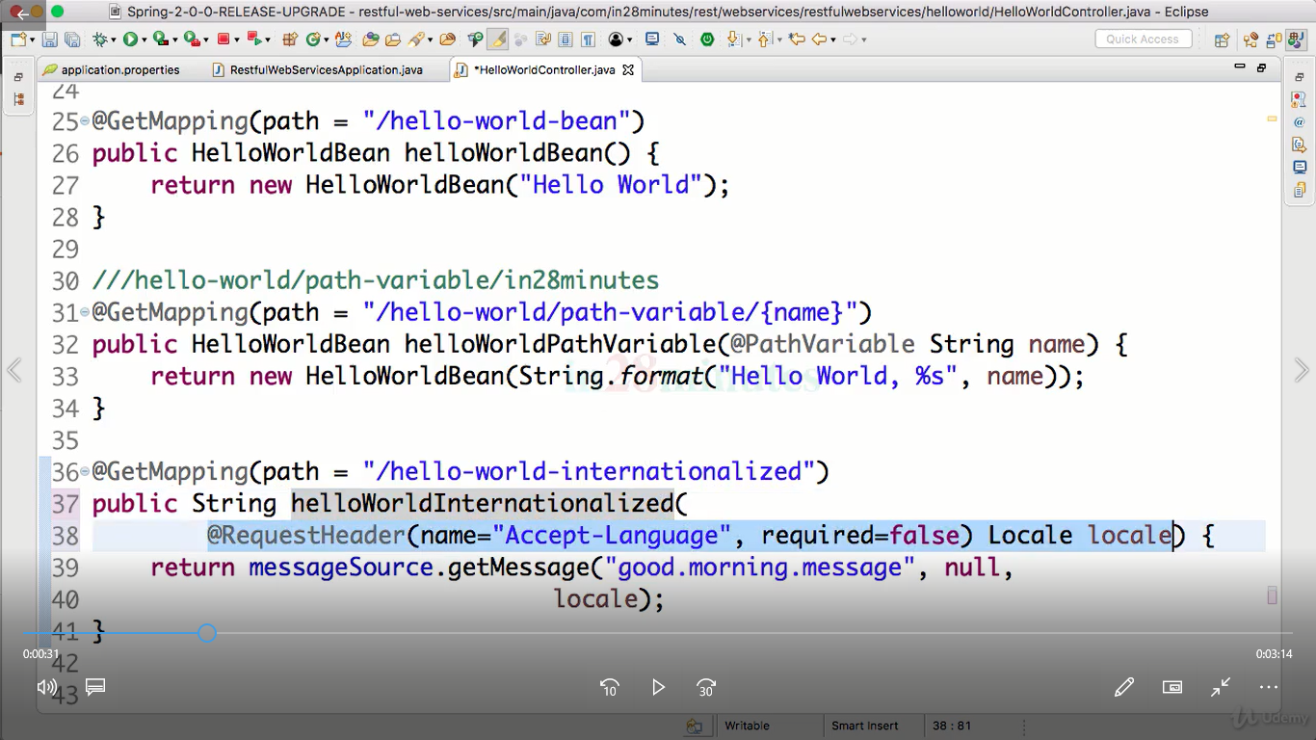

Without usiong @RequestHader:

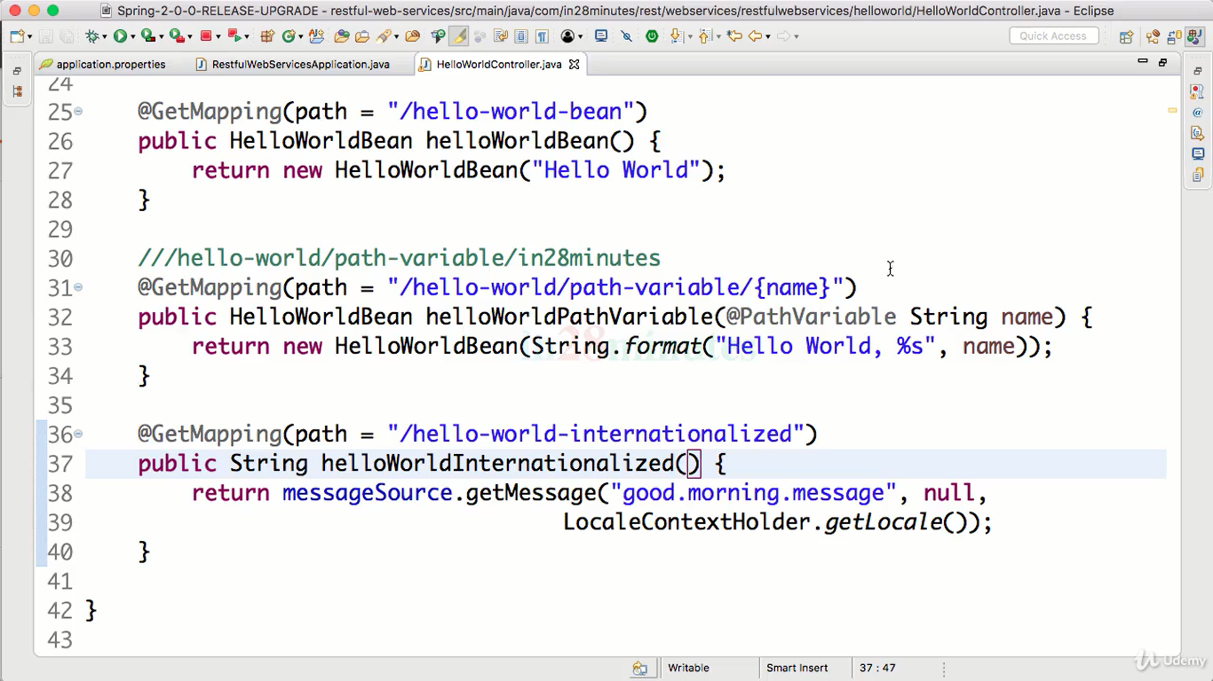

Using AcceptHeaderLocalResolver:

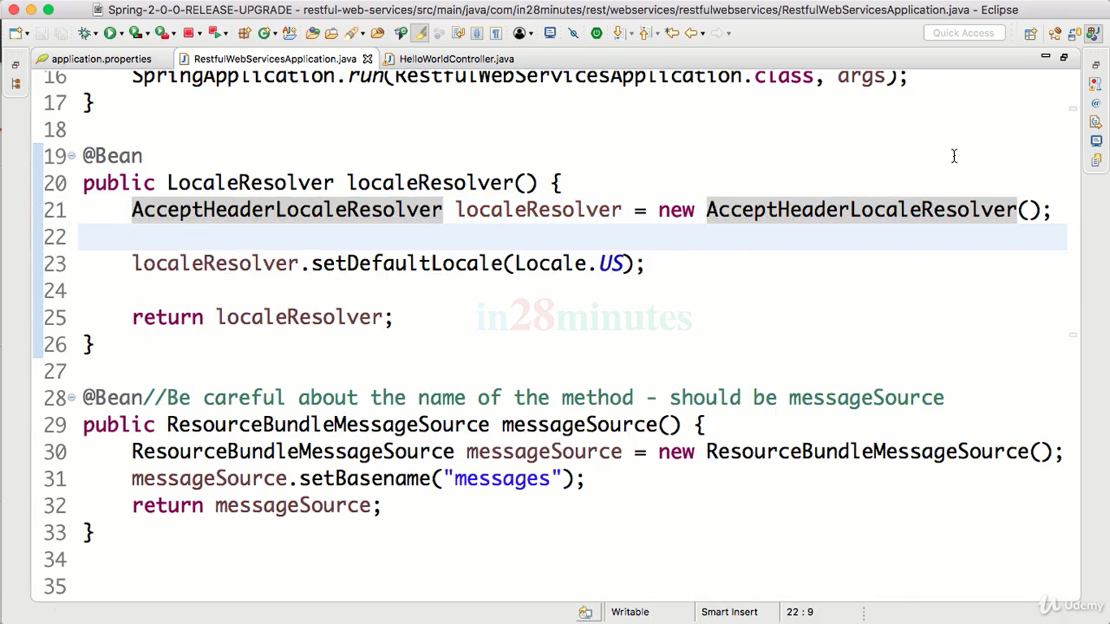

Withour using MessageSoruceResourceBundle:

Using spring.messages.basename

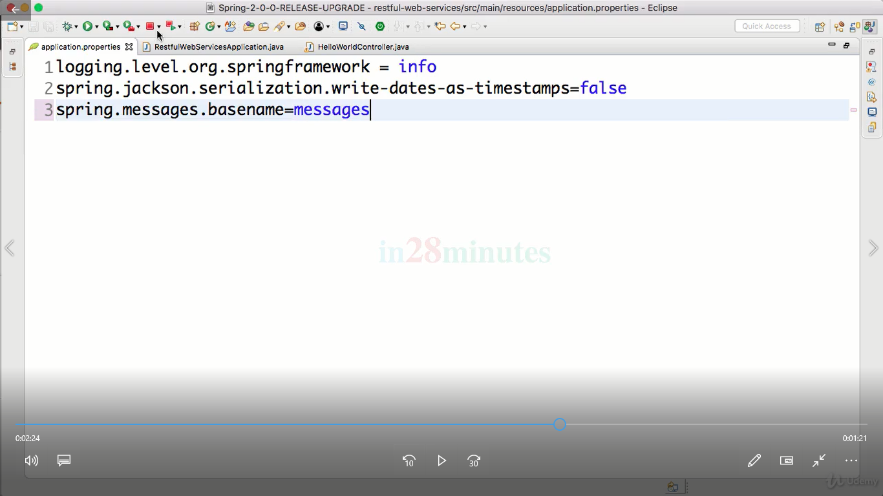

Output:

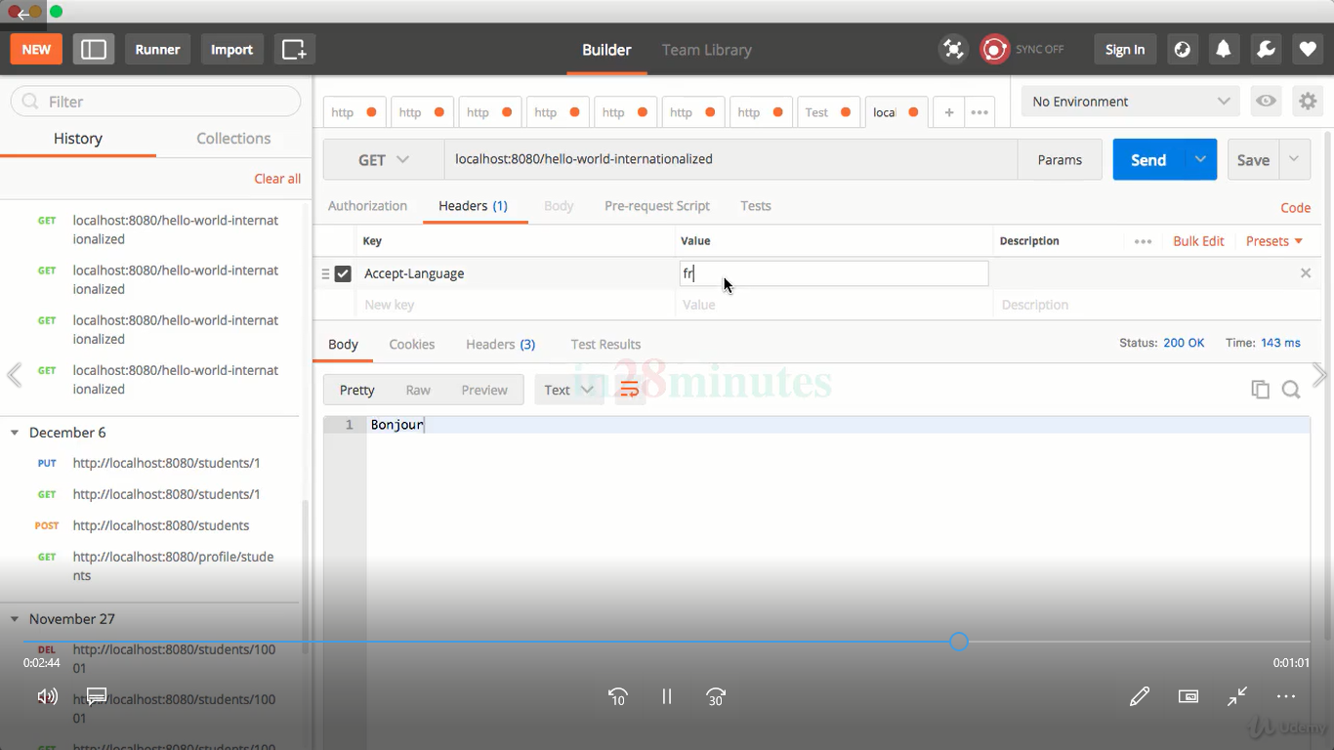

If nothing will be given:

It will use default locale.

**Swagger:**

In order to generate the documenetation out of the endpoint URIS we have developed we used SWaggger.

Documentation is very important for any restful web app because the enduser or the consumer doesn’t understand what exactly particular URI will accept as input and give as output.

There might be large no o f URI’s and we have to document each of it is bvery big task.

So swagger provides documentation atuomtacilly for the endpoint URI’s

Pom.xm,ml:

<!-- https://mvnrepository.com/artifact/io.springfox/springfox-swagger2 -->

<dependency>

<groupId>io.springfox</groupId>

<artifactId>springfox-swagger2</artifactId>

<version>2.9.2</version>

</dependency>

And

<!-- https://mvnrepository.com/artifact/io.springfox/springfox-swagger-ui -->

<dependency>

<groupId>io.springfox</groupId>

<artifactId>springfox-swagger-ui</artifactId>

<version>2.9.2</version>

</dependency>

Create a swagger config class:

@EnableSwagger2

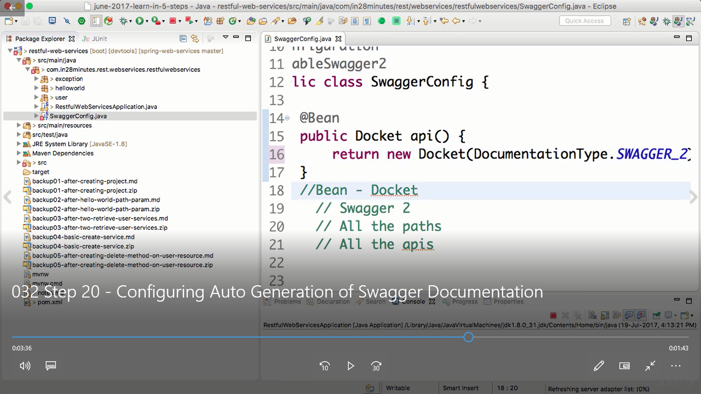

It used Docket to build the docu0menation.

And run the app.

Swagger will prodivde the application documentation I n 2 eays:

1. Localhost:8080/v2/api-docs _> give this url
2. Swagger ui running at localhost:8080 -> give this UI to end user

Swagger documeantion formats:

Mqainly it has

-info-> information about the versioning and contact information and software license info.

-tags -> group of URI’s to gehter

-path _. Endpoint URI’s

-description -> all the return types + entities of web app

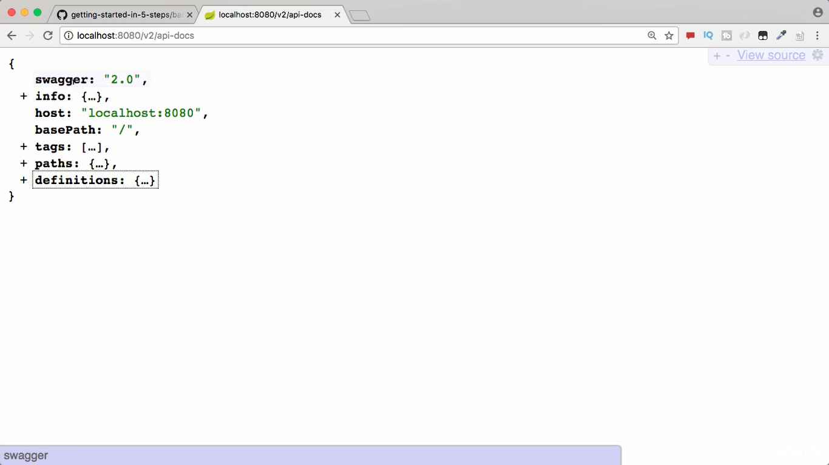

WE CAN CUSTOMIZE THE DOCUMENTATION OF THE SWAGGER IN OUR WEB APP USING DOCKET.

i.e

swagger with custom annotations.

Like:

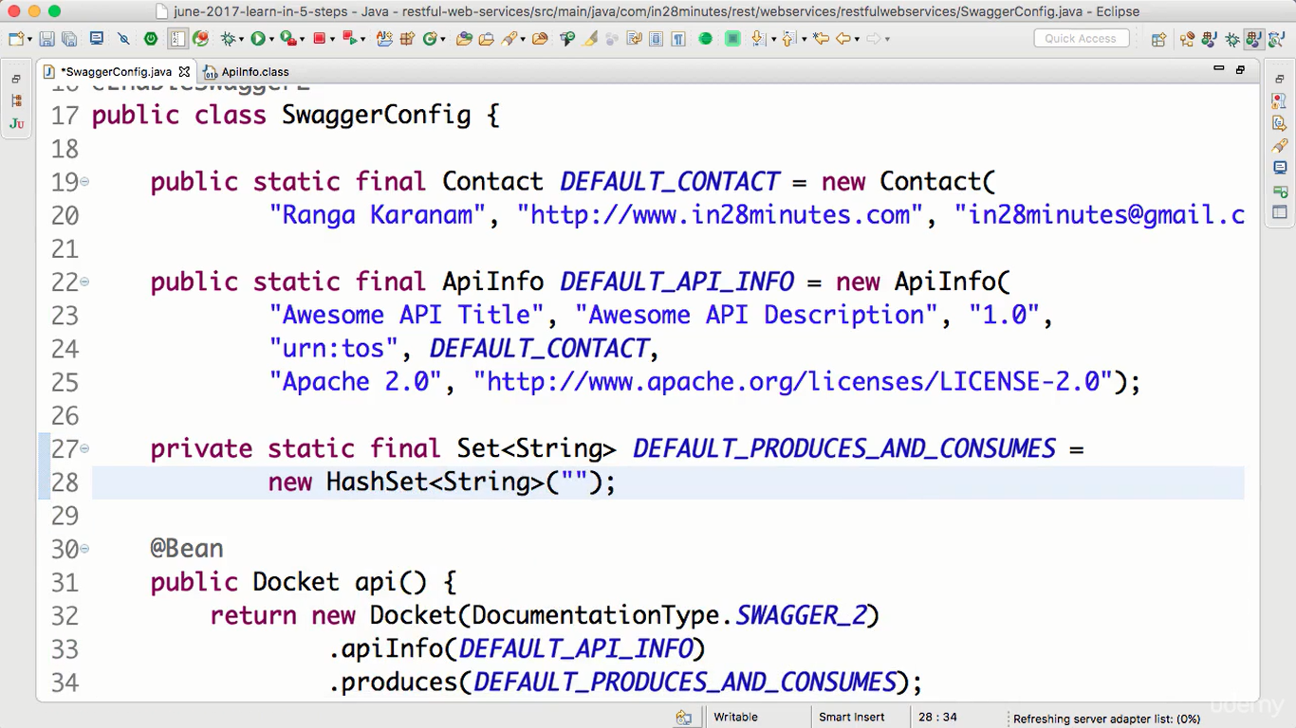

Application json/xml giving:== and produces method:

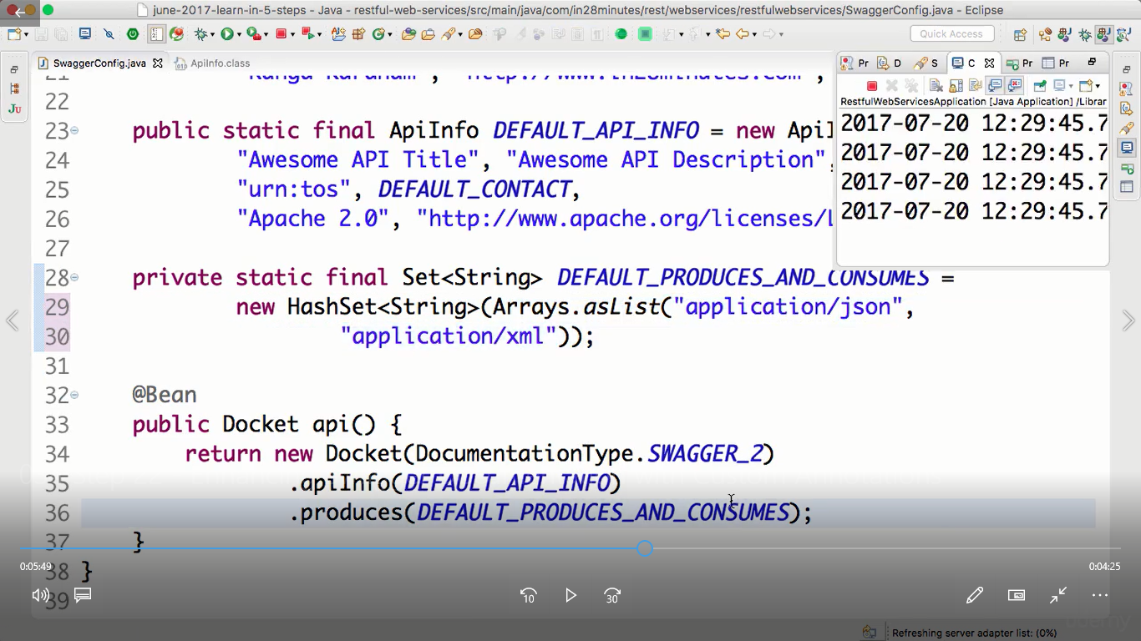

NOTE: IF WE WANT TO HAVE THE DOCUMENTATION TO INCLUDE THE VALIDATION ON THE FIELDS OF THE ENTITY CLASS , WE MUST USE @ApiModel custom annotations to refelec the same in swagger documentation,

Example:

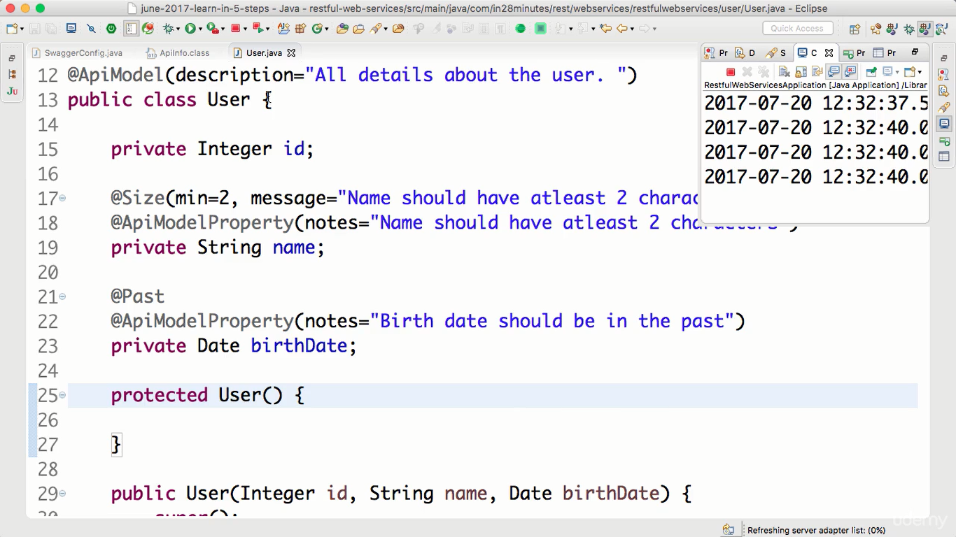

You will get as per the fields given here in the documentation.

Filtering the reponses:

We might have a rewquirement to filter the fieldsand send them as a response.

We can achieve in this 2 ways:

1. Static filtering:

We will achieve this with helog og @JsonIgnore and @JsonIgnorePropeties(//fields) annotations.

1. Create Somebean class with fields and construcotrr setters and getters.

And give @JsonIgnore anno.

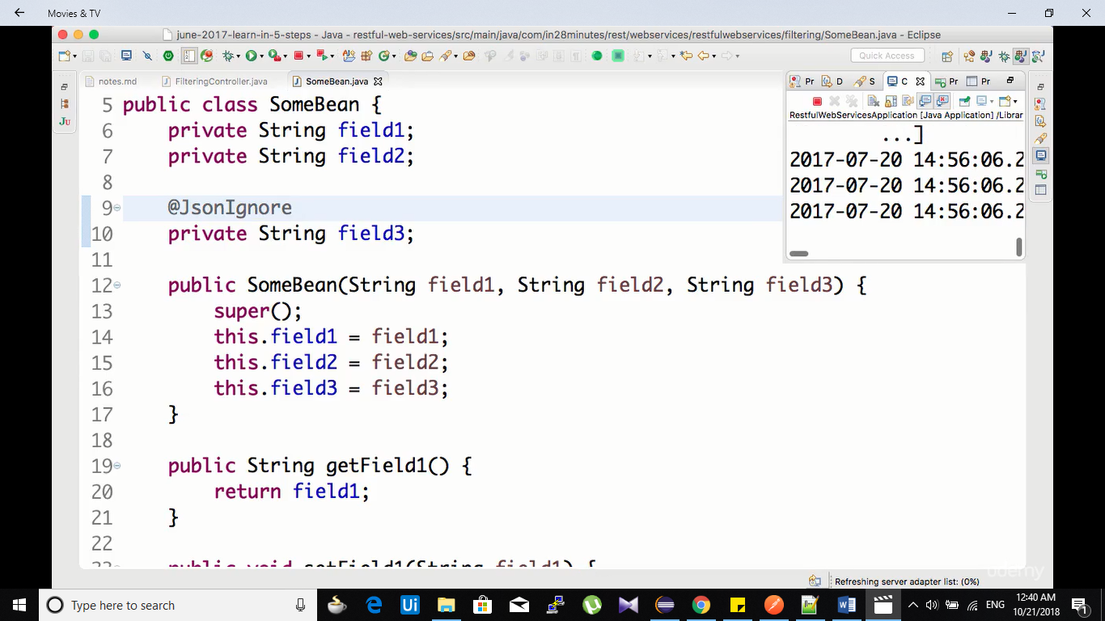

Create filtering class and assign filters.

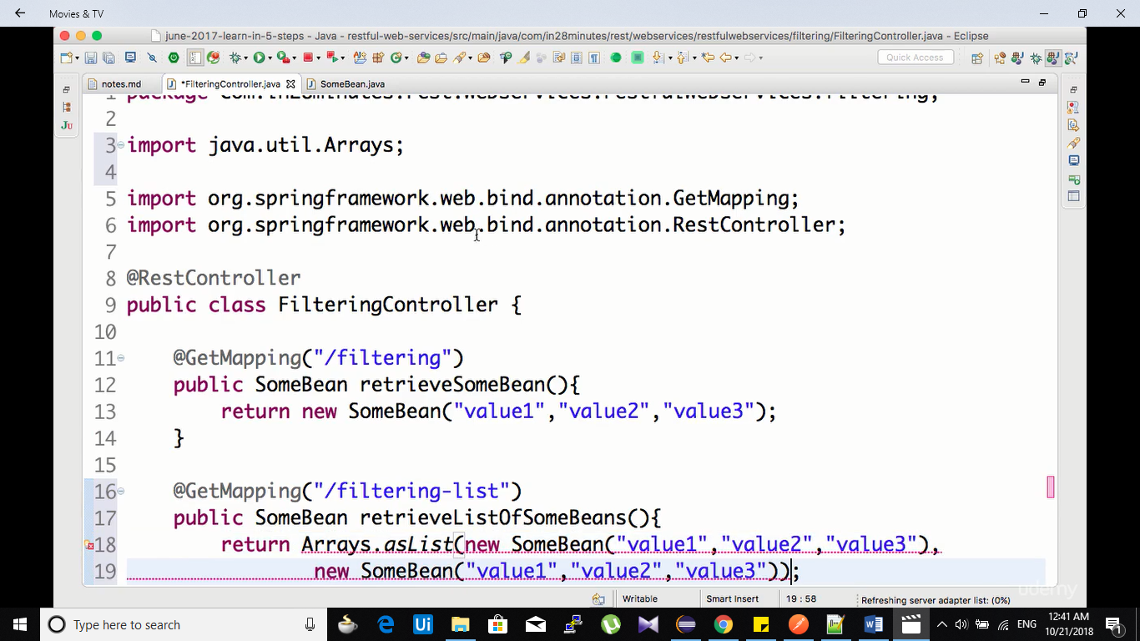

Another method:

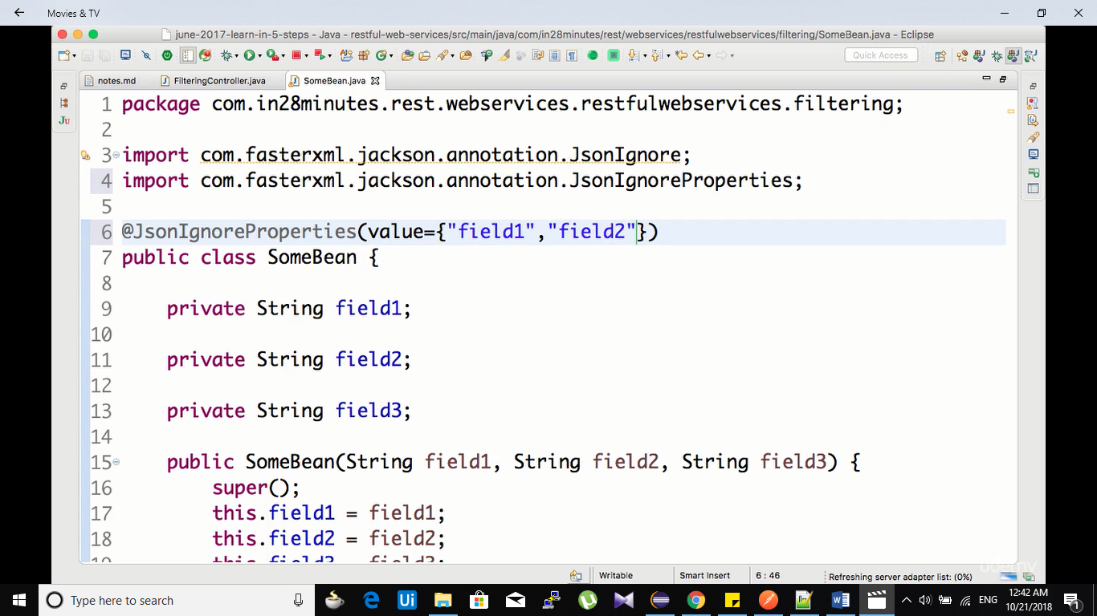

Outout:

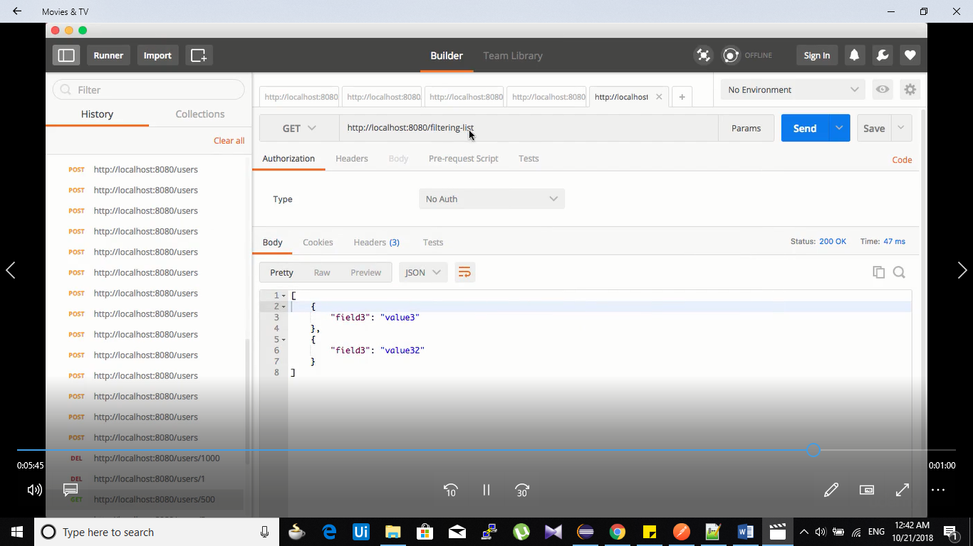

Dynamic filtering:

If we wan tto pass the fields in response removing dynamicallu without touching the somebean or entity bean we use dynamic fiulterning.

How?

Create Somebean class with fields and construcotrr setters and getters.

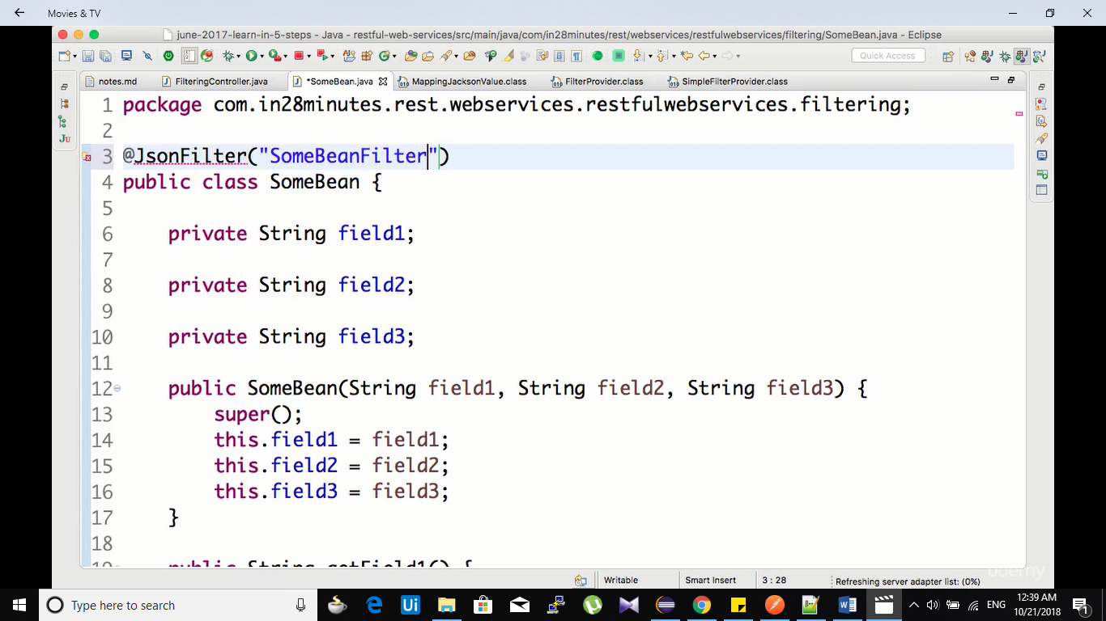

**Create controller class with mqppings:**

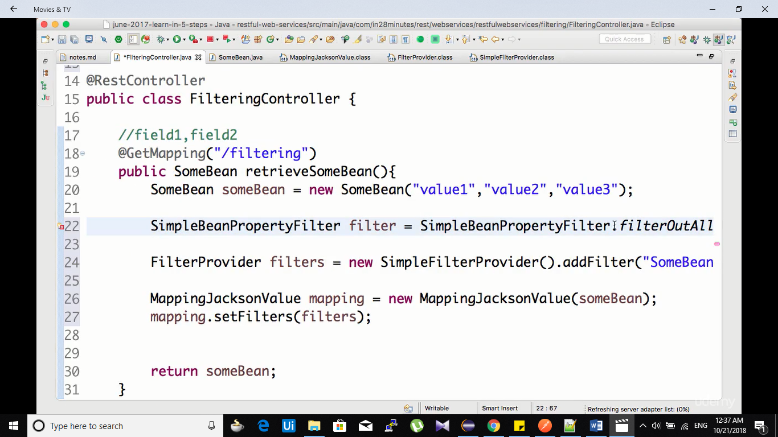

**Create filetring class and give this configs:**

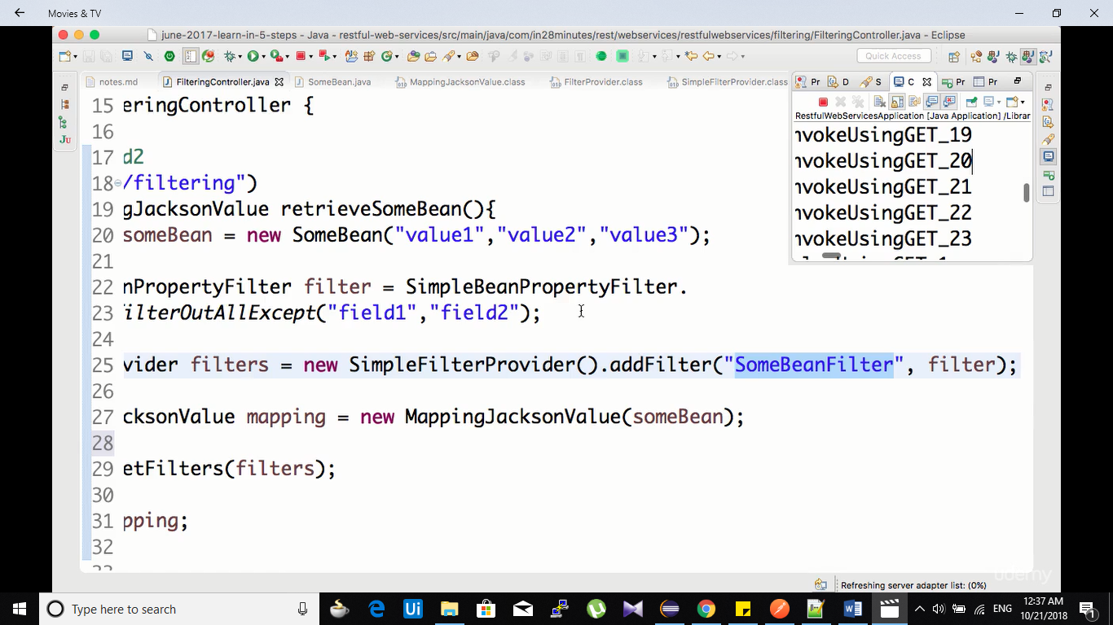

**Returning set of fields we h=wan to:**

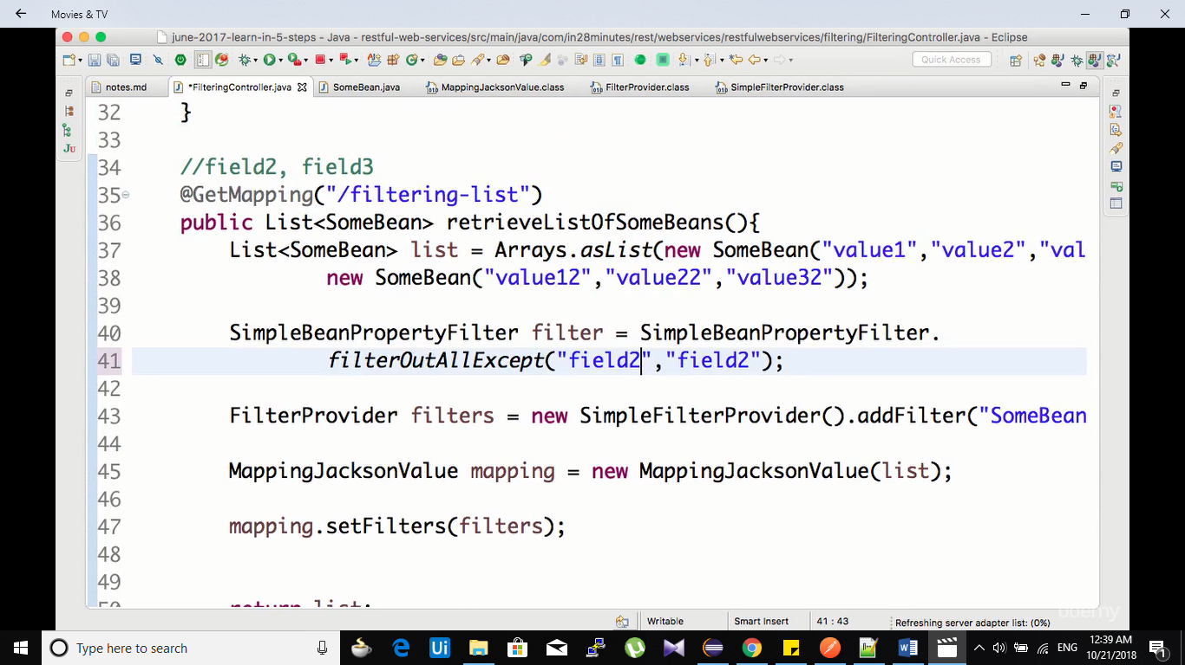

**return mapping for filetrring_list**

**Output:**

